**LAB 2**

Author:

|  |  |
| --- | --- |
| **Abhirup Ranjan** | **110091866** |

Submitted To:

|  |
| --- |
| **Professor** |
| **Dr. Shafaq Khan** |

**Table of Contents**

1. Part 1: 2

2. Part 2 10

# **Part 1:**

1. **Create a database <yourfirstname>vertical.**

CREATE DATABASE AbhirupVertical;

1. **Create a table “Product” table with the following columns: id, name, description, price, category, brand, and quantity. (Note: Insert 10 rows of data in this table)**

CREATE TABLE Product

(

ID int IDENTITY (1,1) NOT NULL,

Name varchar (50),

Description varchar (100),

Price decimal(10,2),

Category varchar (20),

Brand varchar (20),

Quantity int

CONSTRAINT Product_PK PRIMARY KEY CLUSTERED (Id)

)

INSERT INTO dbo.Product(Name,Description, Price, Category, Brand, Quantity)

VALUES

('Name1','Des1', 10.00, 'Category1', 'BrandName1', 10),

('Name2','Des2', 20.0, 'Category2', 'BrandName2', 20),

('Name3','Des3', 30.3, 'Category3', 'BrandName3', 30),

('Name4','Des4', 40.4, 'Category4', 'BrandName4', 40),

('Name5','Des5', 50.5, 'Category5', 'BrandName5', 50),

('Name6','Des6', 60.6, 'Category6', 'BrandName6', 60),

('Name7','Des7', 70.7, 'Category7', 'BrandName7', 70),

('Name8','Des8', 80.8, 'Category8', 'BrandName8', 80),

('Name9','Des9', 90.9, 'Category9', 'BrandName9', 90),

('Name10','Des10', 100.11, 'Category10', 'BrandName10', 10);

SELECT * FROM Product;

1. Apply vertical partitioning by dividing the above table into two partition tables:

* “ProductBasic” table (Columns: id, name, description and category).

CREATE TABLE ProductBasic

(

Id int FOREIGN KEY REFERENCES Product (Id),

Name varchar(50),

Description varchar (100),

Category varchar (20),

CONSTRAINT PK_ProductBasic PRIMARY KEY CLUSTERED (Id)

)

INSERT INTO ProductBasic(ID, Name, Description, Category)

VALUES

(1,'Name1','Des1', 'Category1'),

(2,'Name2','Des2', 'Category2'),

(3,'Name3','Des3', 'Category3'),

(4,'Name4','Des4', 'Category1'),

(5,'Name5','Des5', 'Category2'),

(6,'Name6','Des6', 'Category3'),

(7,'Name7','Des7', 'Category1'),

(8,'Name8','Des8', 'Category2'),

(9,'Name9','Des9', 'Category3'),

(10,'Name10','Des10', 'Category1');

SELECT * FROM ProductBasic;

* “ProductDetails” table (Columns: id, price, brand, quantity)

CREATE TABLE ProductDetails

(

ID int NOT NULL,

Price decimal(10,2),

Brand varchar (20),

Quantity int

CONSTRAINT PK_ProductDetails PRIMARY KEY CLUSTERED (Id)

)

INSERT INTO ProductDetails(ID,Price, Brand, Quantity)

VALUES

(1,10.00,'BrandName1', 10),

(2,20.01,'BrandName2', 20),

(3,30.03,'BrandName3', 30),

(4,40.04,'BrandName4', 40),

(5,50.05,'BrandName5', 50),

(6,60.06,'BrandName6', 60),

(7,70.07,'BrandName7', 70),

(8,80.08,'BrandName8', 80),

(9,90.09,'BrandName9', 90),

(10,100.11,'BrandName10', 100);

SELECT * FROM ProductDetails;

1. Calculate the query performance of each table by retrieving the same ‘id’ from three tables.

SET STATISTICS IO ON

SET STATISTICS TIME ON

SELECT ID

FROM Product

WHERE ID = 1

SET STATISTICS IO OFF

SET STATISTICS TIME OFF

SET STATISTICS IO ON

SET STATISTICS TIME ON

SELECT ID

FROM ProductBasic

WHERE ID = 1

SET STATISTICS IO OFF

SET STATISTICS TIME OFF

SET STATISTICS IO ON

SET STATISTICS TIME ON

SELECT ID

FROM ProductDetails

WHERE ID = 1

SET STATISTICS IO OFF

SET STATISTICS TIME OFF

1. Retrieve basic information of all products in a specific category from the “ProductBasic” table.

SELECT * FROM ProductBasic

WHERE

Category = 'Category1'

1. Retrieve the price and brand of a specific product from the “ProductDetails” table.

SELECT Price, Brand FROM ProductDetails

WHERE

Brand = 'BrandName1'

# **Part 2**

1. Create a database <yourfirstname>horizontal.

CREATE DATABASE AbhirupHorizontal

1. Create a table “Birthday” table with the following columns: s.no, name, date, month (01 - 06) and year. (Note: Insert 20 rows of data in this table).

CREATE TABLE Birthday

(

SNo int IDENTITY (1,1) NOT NULL,

Name varchar (50),

Date int,

Month int,

Year int,

CONSTRAINT Birthday_PK PRIMARY KEY CLUSTERED (SNo)

);

INSERT INTO Birthday(Name, Date, Month, Year)

VALUES

('Abhirup', 26, 3, 1994),

('Rohit', 1, 4, 1993),

('Rat', 2, 5, 1992),

('A', 3, 6, 1991),

('B', 4, 7, 1990),

('C', 5, 8, 1989),

('D', 6, 9, 1988),

('E', 7, 10, 1987),

('F', 8, 11, 1986),

('G', 9, 12, 1985),

('H', 10, 1, 1984),

('I', 11, 2, 1983),

('J', 12, 3, 1982),

('K', 13, 4, 1981),

('L', 14, 5, 1994),

('M', 15, 6, 1995),

('N', 16, 7, 1996),

('O', 17, 8, 1997),

('P', 18, 9, 1998),

('Q', 19, 10, 1999);

SELECT * FROM Birthday

3) Create filegroups within the database to divide them by month.

ALTER DATABASE AbhirupHorizontal ADD FILEGROUP January;

ALTER DATABASE AbhirupHorizontal ADD FILEGROUP February;

ALTER DATABASE AbhirupHorizontal ADD FILEGROUP March;

ALTER DATABASE AbhirupHorizontal ADD FILEGROUP April;

ALTER DATABASE AbhirupHorizontal ADD FILEGROUP May;

ALTER DATABASE AbhirupHorizontal ADD FILEGROUP June;

ALTER DATABASE AbhirupHorizontal ADD FILEGROUP July;

ALTER DATABASE AbhirupHorizontal ADD FILEGROUP August;

ALTER DATABASE AbhirupHorizontal ADD FILEGROUP September;

ALTER DATABASE AbhirupHorizontal ADD FILEGROUP October;

ALTER DATABASE AbhirupHorizontal ADD FILEGROUP November;

ALTER DATABASE AbhirupHorizontal ADD FILEGROUP December;

**Show the created file Groups.**

SELECT data_space_id, name AS AvailableFilegroups, type_desc FROM sys.filegroups

WHERE type = 'FG'

Assigning physical storage location on local machine

ALTER DATABASE [AbhirupHorizontal]

ADD FILE

(

NAME = [Jan],

FILENAME = '/Users/abhirup/Applications/Microsoft SQL Server\MSSQL16.SQLEXPRESS/MSSQL/DATA/AbhirupHorizontal_1.ndf',

SIZE = 3072 KB,

MAXSIZE = UNLIMITED,

FILEGROWTH = 1024 KB

) TO FILEGROUP [January]

ALTER DATABASE [AbhirupHorizontal]

ADD FILE

(

NAME = [Feb],

FILENAME = '/Users/abhirup/Applications/Microsoft SQL Server\MSSQL16.SQLEXPRESS/MSSQL/DATA/AbhirupHorizontal_2.ndf',

SIZE = 3072 KB,

MAXSIZE = UNLIMITED,

FILEGROWTH = 1024 KB

) TO FILEGROUP [February]

ALTER DATABASE [AbhirupHorizontal]

ADD FILE

(

NAME = [Mar],

FILENAME = '/Users/abhirup/Applications/Microsoft SQL Server\MSSQL16.SQLEXPRESS/MSSQL/DATA/AbhirupHorizontal_3.ndf',

SIZE = 3072 KB,

MAXSIZE = UNLIMITED,

FILEGROWTH = 1024 KB

) TO FILEGROUP [March]

ALTER DATABASE [AbhirupHorizontal]

ADD FILE

(

NAME = [Apr],

FILENAME = '/Users/abhirup/Applications/Microsoft SQL Server\MSSQL16.SQLEXPRESS/MSSQL/DATA/AbhirupHorizontal_4.ndf',

SIZE = 3072 KB,

MAXSIZE = UNLIMITED,

FILEGROWTH = 1024 KB

) TO FILEGROUP [April]

ALTER DATABASE [AbhirupHorizontal]

ADD FILE

(

NAME = [May],

FILENAME = '/Users/abhirup/Applications/Microsoft SQL Server\MSSQL16.SQLEXPRESS/MSSQL/DATA/AbhirupHorizontal_5.ndf',

SIZE = 3072 KB,

MAXSIZE = UNLIMITED,

FILEGROWTH = 1024 KB

) TO FILEGROUP [May]

ALTER DATABASE [Rohithorizontal]

ADD FILE

(

NAME = [Jun],

FILENAME = '/Users/abhirup/Applications/Microsoft SQL Server\MSSQL16.SQLEXPRESS/MSSQL/DATA/AbhirupHorizontal_6.ndf',

SIZE = 3072 KB,

MAXSIZE = UNLIMITED,

FILEGROWTH = 1024 KB

) TO FILEGROUP [June]

ALTER DATABASE [AbhirupHorizontal]

ADD FILE

(

NAME = [Jul],

FILENAME = '/Users/abhirup/Applications/Microsoft SQL Server\MSSQL16.SQLEXPRESS/MSSQL/DATA/AbhirupHorizontal_7.ndf',

SIZE = 3072 KB,

MAXSIZE = UNLIMITED,

FILEGROWTH = 1024 KB

) TO FILEGROUP [July]

ALTER DATABASE [AbhirupHorizontal]

ADD FILE

(

NAME = [Aug],

FILENAME = '/Users/abhirup/Applications/Microsoft SQL Server\MSSQL16.SQLEXPRESS/MSSQL/DATA/AbhirupHorizontal_8.ndf',

SIZE = 3072 KB,

MAXSIZE = UNLIMITED,

FILEGROWTH = 1024 KB

) TO FILEGROUP [August]

ALTER DATABASE [AbhirupHorizontal]

ADD FILE

(

NAME = [Sep],

FILENAME = '/Users/abhirup/Applications/Microsoft SQL Server\MSSQL16.SQLEXPRESS/MSSQL/DATA/AbhirupHorizontal_9.ndf',

SIZE = 3072 KB,

MAXSIZE = UNLIMITED,

FILEGROWTH = 1024 KB

) TO FILEGROUP [September]

ALTER DATABASE [AbhirupHorizontal]

ADD FILE

(

NAME = [Oct],

FILENAME = 'C:\Program Files\Microsoft SQL Server\MSSQL16.SQLEXPRESS\MSSQL\DATA\Rohithorizontal_10.ndf',

SIZE = 3072 KB,

MAXSIZE = UNLIMITED,

FILEGROWTH = 1024 KB

) TO FILEGROUP [October]

ALTER DATABASE [AbhirupHorizontal]

ADD FILE

(

NAME = [Nov],

FILENAME = '/Users/abhirup/Applications/Microsoft SQL Server\MSSQL16.SQLEXPRESS/MSSQL/DATA/AbhirupHorizontal_11.ndf',

SIZE = 3072 KB,

MAXSIZE = UNLIMITED,

FILEGROWTH = 1024 KB

) TO FILEGROUP [November]

ALTER DATABASE [AbhirupHorizontal]

ADD FILE

(

NAME = [Dec],

FILENAME = '/Users/abhirup/Applications/Microsoft SQL Server\MSSQL16.SQLEXPRESS/MSSQL/DATA/AbhirupHorizontal_12.ndf',

SIZE = 3072 KB,

MAXSIZE = UNLIMITED,

FILEGROWTH = 1024 KB

) TO FILEGROUP [December]

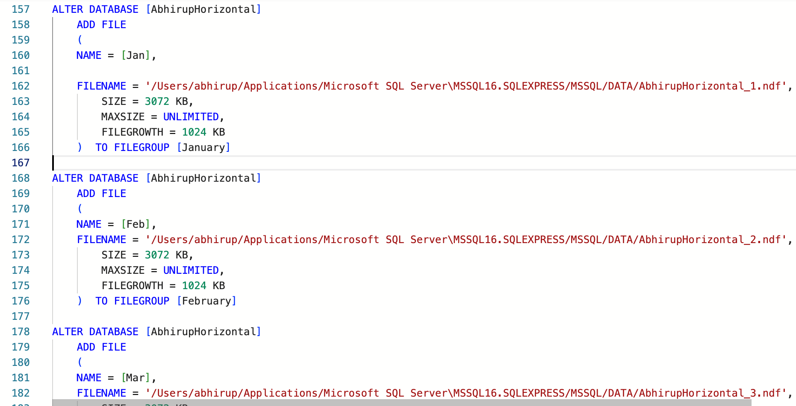

4) Create a partition function <yourfirstname>ByMonth (Note: The datatype of the month to be integer).

CREATE PARTITION FUNCTION [AbhirupByMonthADT] (int)

AS RANGE RIGHT FOR VALUES (1, 2, 3, 4, 5, 6, 7, 8, 9, 10, 11, 12)

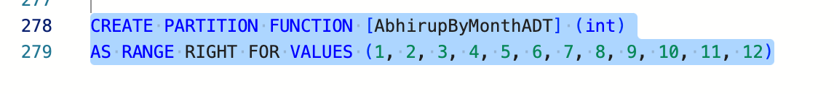

5) Create a partition scheme <yourfirstname>ByMonthADT.

CREATE PARTITION SCHEME AbhirupByMonthADT

AS PARTITION AbhirupByMonth

TO ( FG_JAN,

FG_JAN,

FG_FEB,

FG_MAR,

FG_APR,

FG_MAY,

FG_JUN);

6) create or modify a table and specify the partition scheme as the storage location to segment the data out and store it within the appropriate file group.

CREATE TABLE BirthdayMonth

(Id int IDENTITY (1,1) NOT NULL,

BirthdayMonth int NOT NULL,

PRIMARY KEY (BirthdayMonth, Id))

ON AbhirupByMonthADT(BirthdayMonth);

INSERT BirthdayMonth VALUES

(1),

(2),

(3),

(4),

(5),

(5),

(6),

(7),

(8),

(9),

(10),

(11),

(12);

SELECT * from BirthdayMonth

1. Write a query to check the number of records in each partition.

SELECT $PARTITION.AbhirupByMonthADT(BirthdayMonth) AS Partition, COUNT(*) AS [COUNT] FROM BirthdayMonth

GROUP BY $PARTITION.AbhirupByMonthADT(BirthdayMonth) ORDER BY Partition;

8) Execute the records in partition number 3.

SELECT * FROM BirthdayMonth

WHERE $PARTITION.AbhirupByMonthADT(BirthdayMonth) = 3

